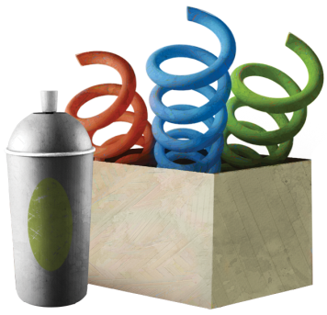
VBS Supplies
Please consider donating supplies for VBS. We would love to have these supplies ASAP!
-Dinner Plates in bright colors and patterns
-Pool Noodles – We need 50 of these!
-Appliance boxes
-Large Cans – The size a restaurant get pizza sauce in
-Frisbees- any size or color
-Concrete Forms
-Carpet Tubes
-Spray Paint- bright colors, partially used are fine
-Slinkies- variety of sizes and colors
-Hula hoops
-Empty water bottles with lids
-Small plates for snacks
-Napkins for snack
Updated June 11th
-6 oz. cups for snack
-Sandwich bags for snack
-Quart bags for snack
-Plastic knives for snack
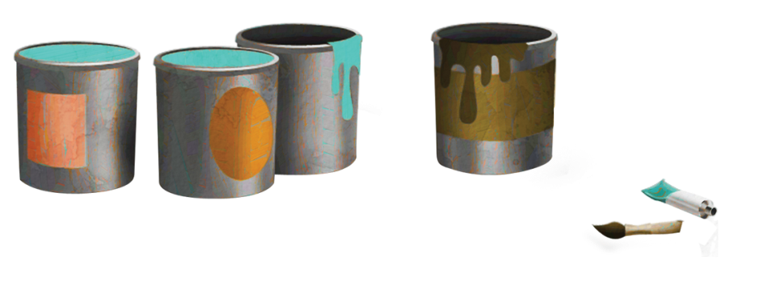

VBS Supplies
Please consider donating supplies for VBS. We would love to have these supplies ASAP!
-Dinner Plates in bright colors
-Pool Noodles – We need 50 of these!
-Appliance boxes
-Large Cans – The size a restaurant get pizza sauce in
-Frisbees- any size or color
-Concrete Forms
-Carpet Tubes
-Spray Paint- bright colors, partially used are fine
-Slinkies- variety of sizes and colors
-Hula hoops
-Empty water bottles with lids
-Small plates for snacks
Updated June 11th
-Napkins for snack
-6 oz. cups for snack
-Sandwich bags for snack
-Quart bags for snack
-Plastic knives for snack

Robots Needed
Want a fun activity to do with your family? Make a robot!

They will be placed around the building as decorations for vbs. Please drop off all creations at church by June 26th. If you would like it back when we are done, make sure your name and phone number are on it. Please pick it up by July 31st.
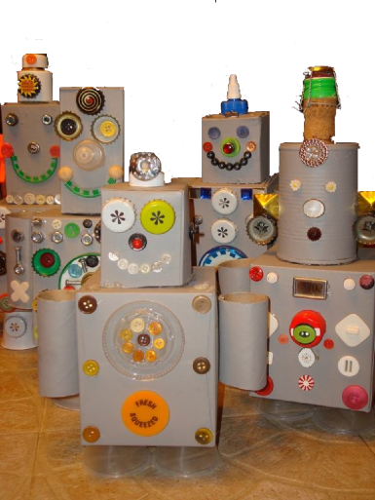
Get creative!
Use supplies around
your house!
Have fun!

Robots Needed
Want a fun activity to do with your family? Make a robot!

They will be placed around the building as decorations for vbs. Please drop off all creations at church by June 26th. If you would like it back when we are done, make sure your name and phone number are on it. Please pick it up by July 31st.
Get creative!
Use supplies around
your house!
Have fun!

