**SPUMCNS INFORMATION AND PARENT HANDBOOK 2019-2020**

**SPUMC Nursery School**

**731 Benfield Rd., Severna Park, MD 21146 Office**

**Phone: 410-987-8339**

**Office Hours: 8:30 am to 3:00 pm, Monday through Friday**

**Tax ID Number: 52-0897890**

**Website:** [www.severnaparkumc.org/nursery](http://www.severnaparkumc.org/nursery)

**Facebook page:** [www.facebook.com/spumcns](http://www.facebook.com/spumcns)

**Director: Heidi Taflan - email:** [spumcns@gmail.com](mailto:spumcns@gmail.com)

**Treasurer/Registrar - email:** rdecker@spumcns.org

**1) SPUMCNS Philosophy**

Our preschool provides an enriching educational program of love, learning and fun, as an extension of the home, for children 3 and 4 years old.

Our students learn through first-hand experiences. Our state-approved curriculum offers wide and varied experiences in art, music, literature, the natural and physical sciences, the Christian faith, and community life. It opens the door to new interests and enriches already existing ones. It provides children with opportunities to work, learn, and play as they develop and grow.

Within this framework, and under the teacher’s and assistant’s thoughtful and empathetic guidance, each child develops trusting relationships with adults outside the family, learns to exercise self-control, increases independence, develops creativity, explores and discovers, and develops critical thinking skills. In short, SPUMC Nursery School helps each child develop, regardless of his or her unique differences, a love of learning and the interpersonal, academic, social, and spiritual tools needed for success.

Our school offers these experiences through half-day and extended-day sessions. Each classroom of no more than 12 three-year-olds or 14 four-year-olds is taught by a qualified teacher and a teaching assistant.

**2) CERTIFICATION**

Our school operates under Certificate of Approval # 3710, issued by the Maryland State Department of Education. All our teachers have, at a minimum, a bachelor’s degree, as do some of our teaching assistants. Everyone undergoes a background check and is selected based on ability, interests, and experience with young children. Our classes have a maximum student/teacher ratio of 6:1 (for 3-year-olds) or 7:1 (for 4-year-olds)

**3)** **POSITIVE BEHAVIORAL PRACTICES**

To help our students develop self-control and to reinforce behavior that is kind, respectful, and positive, we employ “conscious discipline,” techniques. Conscious Discipline is a comprehensive classroom management and social-emotional program that creates a learning environment where children feel safe and loved.

From this foundation of safety and caring, children begin learning how to manage their emotions and interact appropriately with their peers. “Self-regulation is the key to school readiness and more powerful than IQ as a predictor of academic achievement.” Becky Bailey, Ph.D.

**4) INCLUSION**

We welcome all children, regardless of their race, color, religion, ethnic origin, developmental abilities or educational needs. Regardless of the challenges children may face, all children can learn, and all children will be invited to participate in everyday routines and activities to the best of their capabilities. The Frog Street™ curriculum used at this school includes specific guidelines to help our educators in working with children with special needs. If your child is receiving community-based services, such as speech or occupational therapy, please obtain a release form at the office to sign so we can work with the other professionals providing support to your child, exchange information and participate in IEP meetings.

**5) COMMUNICATION**

**During school hours, always monitor your phone**. If we need to reach you because your child is sick, we will call the phone number you have indicated on your emergency form. A monthly activity calendar and the monthly snack schedule will be posted on the bulletin board in the school entryway. Always check the walls outside your child’s classroom for notices and sign-up-sheets and watch for important notes pinned on your child’s bag. In addition to using Bloomz, your child’s room parent may set up a notification network or system for your classroom. Daily conversations with the teaching staff is always possible at drop-off and dismissal; however, more lengthy conversations are best arranged via appointment with the teacher. Phone calls/emails to teachers will be returned prior to the next school day. The school uses a variety of methods to communicate reminders and important information, so make sure to notify us if your phone number, address, or email address changes.

* **BLOOMZ** – The school uses Bloomz, an easy-to-use, secure app, to communicate between parents and guardians, staff, and the parent group. Be sure to sign up for both the school and the classroom groups on Bloomz so you receive all messages, announcements, calendar updates, and alerts.

**6) CURRICULUM**

The Frog Street™ curriculum is a comprehensive, research-based program that integrates instruction across developmental domains and early learning disciplines. The program is engaging for children and encourages daily routines, intentional instruction, thematic activities and balances teacher-directed with child-directed play. The curriculum embraces the joy of learning each day and is endorsed by Maryland State Department of Education.

**7) CHILD ASSESSMENT**

We use ongoing assessment to identify a child’s current abilities to plan individualized activities; note developmental progress, concerns or delays; and guide instruction. Developmental screening is used to identify children with potential learning differences so strategies for appropriate intervention can then be implemented. Progress reports will be sent home in January and May. Parent-Teacher Conferences are held in January for all students by appointment, and can be scheduled upon request during the school year

**8) TUITION AND ENROLLMENT**

To enroll, your child must be three or four by September 1. Once at full capacity, new enrollments are accepted throughout the year as openings arise. Children on the “wait list” are offered available spots in the order of the date they were added to the list. We welcome all parents and children interested in attending the school to come in for a tour.

When you enroll your child, we reserve a place for him/her in a class for the entire school year. The tuition, therefore, is a yearly obligation which we collect in eight equal payments. Tuition payments will be collected through Tuition Express on the first business day of the month, from September through April. May tuition will be covered by your tuition deposit. Parents of enrolled students can go to [www.myprocare.com](http://www.myprocare.com) to view account statements, make early payments and print tax documentation.

**9) NUTRITION**

SPUMCNS is a **NUT-FREE AND PEANUT-FREE** school. We serve a nutritious, simple, and easy-to-serve snack during each school session, and we post a monthly snack calendar on the bulletin board in the foyer. Please advise us of **any** food allergies your child may have. Parents of children with dietary restrictions must provide their child’s snack. Please provide a shoebox-sized plastic bin, labeled with your child’s name, filled with a selection of appropriate snacks individually packaged with your child’s name written on every item. We will choose which snack best matches the school’s snack for the day. Remember to replenish the snack box regularly through the year.

**10) ARRIVAL AND DISMISSAL**

During each session drop off period the doors to the school are briefly unlocked. For safety and security, the doors to the school are locked and alarmed during the remaining school hours.

At dismissal, you may pick up your child at the playground or wait for him/her in the car line. In either case, please hold up or hang the card tag with your child’s name on it. Once we begin the car line, we won’t dismiss any students on foot until the car line is completed.

In the car line, orange traffic cones will mark where the first four cars should wait. If waiting more than 2 minutes or so, please turn off your car until we start dismissing children. Be sure to put your car in “park” while a staff member delivers your child to the back seat of your car and closes the door. Drive forward, park your car and buckle your child into his/her car seat.

**No child will be released to someone other than a parent/guardian without written authorization signed by the parent/guardian. In addition, proper identification will be required for all individuals other than a parent or registered caregiver picking up a child.**

**PLEASE BE ON TIME** for arrival and dismissal. If an emergency arises that will cause you to arrive late, you must call our office and let us know. Late arrivals for pick-up will be charged a $15.00 fee for every five minutes or increment thereof after dismissal.

**11) HEALTH AND SAFETY**

Required medical forms: Must be completed and turned in prior to the first day of school

* Emergency Forms
* Health Inventory
* Medication Administration Authorization Form (if applicable)
* Immunization Certificate
* Asthma Action Plan (for children with diagnosed asthma)
* Allergy Action Plan (for children with documented allergies)

All medical forms are handed available on the school website. **Please provide the school with updated information any time your address, phone number, or emergency information changes.**

Medication Administration – The Medication Administration Form is required if ANY medications (including

epi pens) are to be administered during the school day. Medications will be administered by staff members who have completed Medication Administration Training.

Illness - Please keep your child at home if he/she is sick. Refer to the chart below to determine whether your child should come to school. If your child appears to be sick or develops a fever at school, we will contact you immediately to come pick up your child. A child may not remain at school after showing signs of acute illness.

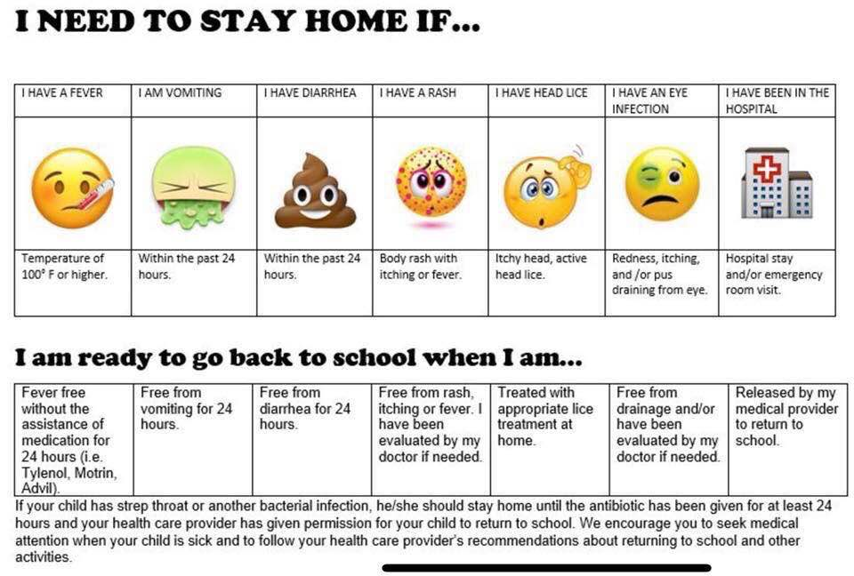

**12) PHYSICAL ACTIVITY**

The benefits of physical activity include releasing energy, developing strong bodies and muscles, and helping to improve coordination and balance. All classes will participate in recess daily, whether on our secured playground or indoors. Please dress children appropriately for outdoor play.

**13) CLOTHING**

Occasionally, children have accidents or soil their clothing at school. Please leave a spare set of clothes (labeled) in a gallon zip lock bag in your child’s tote bag. We have a supply of "extras,” just in case. If your child comes home in an unfamiliar item of clothing, please launder it and send it back as soon as possible.

**Please label all removable clothing** (hats, sweaters, mittens, boots, and coats) as many children wear similar items.

We play outdoors whenever the weather permits; therefore, children should wear appropriate clothing to school. Tied or fastened shoes with a rubbery sole are safest for climbing and running. (Crocs, flip flops, and other open back shoes such as clogs are **NOT** recommended and are a safety hazard.)

**14) "FIRST DAY BLUES"**

Avoid making a big production out of your child going to Nursery School. Be enthusiastic, but casual. Make Nursery School sound like fun. Remind your child of all the children he/she knows, including siblings, who will also be going to school. Your positive attitude is key to your child’s adjustment to preschool.

If your child seems anxious about school at first, arrive just in time for class to start and keep your farewell short. If your child cries or clings to you at drop off, remember: this is normal. It is best to bring your child to the room, tell him/her you must go but that you will be back at the end of the session, and then leave him/her in the staff’s care. We’ll contact you if your child becomes absolutely inconsolable, and we’ll work with you through this transition. Your child's happy adjustment to preschool is importance to us. If you have any concerns about how your child is adjusting to preschool, it’s best to call his/her teacher to discuss your concerns by phone, rather than in the child's presence.

**15) BIRTHDAY PARTIES**

Parents are welcome to provide a special birthday treat for the class. Please consult with your child’s teacher if you wish to furnish a birthday treat, to see if anyone in the class has an allergy and to schedule a date with the teacher. Treats brought into the classroom **MAY NOT CONTAIN PEANUTS OR NUTS.**

**16) TOTE BAG**

We prefer that your child bring a “tote” style bag to school. School tote bags will be available for purchase at Back to School Night for $10/each. Label your child’s tote clearly with his/her name and check it daily for artwork, soiled clothing, newsletters, communications and notices, order forms, and anything else he/she might bring home**. If you’re returning something to the school, please hand it to the teacher at drop-off instead of leaving it in your child’s bag.**

**17) FUNDRAISERS**

The proceeds from fundraisers enable SPUMCNS to host special events and visitors. Participation in any fundraising event is voluntary.

**18) DONATIONS TO THE SCHOOL**

We welcome your contributions to the school, and love it when parents share their talents with the children. If you have any questions about an item you’d like to send in, consult your teacher first. Here are a few suggestions:

Anything for the science/ nature table CD’s suitable for preschoolers

Musical instruments Buttons, etc. for the collage box

Dress-up clothes (vests, jackets, uniforms)

**19) SCHOOL CLOSINGS AND DELAYS**

Changes to normal school hours will be announced on Bloomz. In the event of inclement weather, please monitor radio, television, AACPS.org, for an announcement regarding the county decision on school closings or delays. Our policy is as follows:

If Public Schools open one hour late, we open one hour late.

If Public Schools are two hours late, our AM class is canceled and extended day students start two hours late..

If Public Schools are closed, we are closed.

If Public Schools close one hour early, we close 1 hour early.

If Public Schools close two hours early, our PM class is canceled, and extended day students are dismissed at 11:30 with our AM students.

**Severna Park United Methodist Church Nursery School**

**CPR/First Aid and Emergency Preparedness Plan**

**CPR/First Aid**

All staff members providing direct care are certified in CPR and basic first aid. In the event of an emergency, SPUMCNS will activate the 911 system and immediately notify the family or emergency contact listed on the Emergency Form.

In accordance with state guidelines, we have developed an emergency plan to ensure the safety of the students and staff.

**Fire Drills**

The school holds fire drills monthly. Children are taught to walk quickly and quietly to the far side of the playground, away from the building.

**Tornados or sheltering in place**

If we must take shelter inside the building during an emergency, the staff will take the children to the men’s and ladies’ restrooms in our school hallway across from the preschool office. This area has been declared as safe for sheltering since there are no windows. The staff will have walkie talkies, radios, cell phones and the weather alert radio for communication. The school holds shelter-in-place drills twice a year. If circumstances dictate, we either remain inside classrooms or leave the building. Staff will take appropriate action to protect students and contact parents promptly.

**Catastrophic events and emergency evacuations**

In the event of emergency or adverse conditions that require us to leave the church property, we will walk with the children to Heartlands Assisted Living, across the parking lot from the church. Heartland has graciously given permission for the school to shelter on their sun porch. The staff will have contact numbers, cell phones, emergency food supplies, water, toys, books, etc. to occupy the children.

Parents will be notified by phone or text to pick up their children there.

Heartlands Assisted Living

715 Benfield Road

Severna Park, Maryland 21146

410-729-1600