Special Things about Our Service Today
Are any of the following special extras included today?
Passing the Peace: Share the peace of God’s love with God’s family by saying “Peace be with you” to those around you.
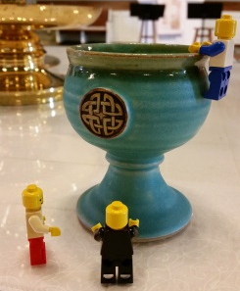
Baptism: A baby, child, or adult is becoming a member of God’s family. This is a special day! During the baptism we will promise to help this person grow in God’s love. How can you help welcome this person into God’s family?
Communion: This is a joyous meal that we share as Christian’s around the world. During communion we give thanks to God, remember Jesus, and celebrate Jesus giving his life for us.
Special Music: Music is a wonderful way to praise God. Is there any special music today? Did a choir sing? What was your favorite song?
Doxology: Sing the doxology together. The word doxology means “to give God glory” in Greek.
Commissioning: We say a special prayer for people doing mission work. Say a prayer that these people do the work of God in the community.
Witnessing: People who do God’s work in the community tell the church about it so we might also go and do God’s work. What did this person do? How can you share God’s love with others?
Welcome to Worship at Severna Park UMC
Welcome! We are glad you are worshipping with us today. There are many ways to worship but these are the four ways we will worship this morning:
Singing to God
Praying to God
Hearing God’s Word
Giving to God

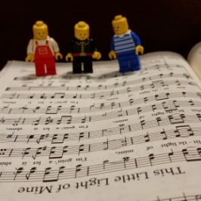
Follow along as we worship:
Prelude: This music helps us feel closer to God and gets us ready to worship. Look around the sanctuary. What do you notice about it today? Are their flowers on the altar? Is there a baptism today? What color are the banners and altar clothes?
Welcome & Call to Worship: We stand together as we are invited to worship.
Hymn: Sing praises to God!
Time of Prayer: We share with God our joys and concerns. Listen for the four parts of a prayer: thanksgiving (thanking God), confession (admitting our faults), petition (asking God for help), and intercession (asking God to help others). Feel free to pray at the altar or in your pew.

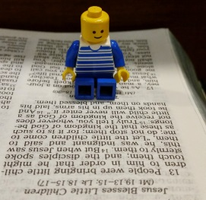
The Lord’s Prayer: This is the prayer Jesus taught us. Join with the congregation in praying it aloud.
Hymn: Sing praises to God!
Scripture Reading: God’s words are written in the Bible. Listen as it is read aloud. Find it in the Bible under the pew and follow along.
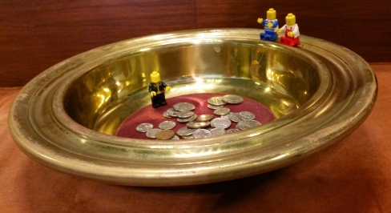
Children’s Message: Hear the story of God’s love with other children.
Sermon: A pastor will talk about what the scripture means. What can it mean for us?
Offering: We give our time, talent, money, and witness because God gives us so much. What can you give?
Hymn: Sing praises to God!
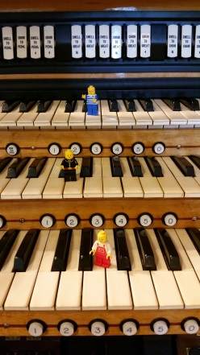
Benediction: Benediction means “good word” and the good word is that God goes with us into the world!
Postlude: We listen to joyful music as we go into the world to love one another.
Today’s Worship:
Scripture Reading: What is the scripture reading this morning?
Book:
Chapter:
Verse:
What did we learn about God from this passage?

What did you learn about you from this passage?

What was your favorite song?

What are you curious about?

Write or draw a picture about today’s service.

