Recognize the order of worship. If your child needs to leave the service to use the restroom or get a drink, please be mindful to do so when it’s least distracting to the worship leaders, the music groups, and the rest of the congregation.

Standing and sitting and standing and sitting is all part of worship. Enjoy the natural movement during the service.

Treat a child as the minister of Christ that he/she is! God has magnificent plans for them and is using them already to do His will!
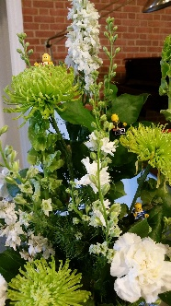
Understand that children need to be taught about the service; the songs and hymns, the prayers, the traditions, the symbols, including banners, flowers, seasonal colors, etc. Take time to teach them!

Visit the sanctuary. Look at all the colors and decorations and banners.

Wiggle, wiggle, wiggle! Stand and wiggle/sway as you sing hymns or move to the music. We know that sometimes your child just needs to move! We encourage you to sit with your fidgety child in the narthex and watch the service through the glass windows.
eXit when necessary. If a child is distressed, overly rambunctious, or has set up a distracting pattern of play with another child, exiting for a few minutes may resolve the issue. When things are resolved, return. Exiting without reentry is counterproductive.

You are your child’s best spiritual leader. Be a positive role model everywhere you go, through all of your actions, words and deeds.

Zzzzz – only for babies! Rocking chairs are available in the nursery and narthex.
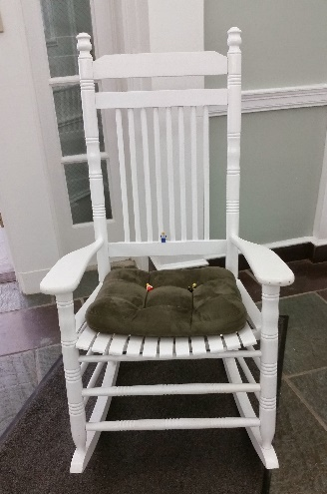
The ABC’s of Children in Worship

Building Faith at
Severna Park
United Methodist Church

Arrive early! Arrive in time to get a good seat close to the front so your child can see well.

Be prepared! Before you arrive at church, be sure that you encourage your child to use the restroom or get a drink of water.

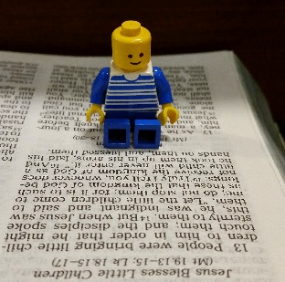
Clue your child into what is happening in worship. Share your bulletin, hymnal and Bible, helping them to follow along.

Discuss the church service and Sunday school lesson at home. Take time to answer questions about their worship experiences.
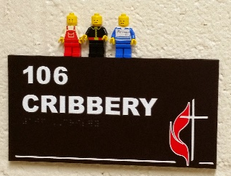
Encourage your child to greet others and introduce themselves.

Fidgeting is to be expected. Create opportunities for your child to move during the service – during the welcoming and the singing of the hymns, for example.
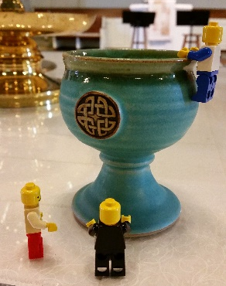
Gather at the Lord’s Table. Bring children to the altar to look at the table colors and to receive communion.

Hugs! Use a gentle touch to give reassurance and attention.

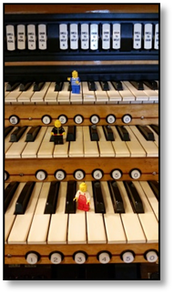
Include your child in worship preparation. Let them help mark the pages you’ll be turning to in the Bible or hymnal.
Jesus said, "Whoever welcomes one of these little children in my name welcomes me; and whoever welcomes me does not welcome me but the one who has sent me." Mark 9:36-37

Keep your child interested in the service by whispering instructions. “Listen to this story. It’s a good one.” “Now is the time we tell God about the things we are sorry we did.” “Remember our talk about being selfish? Tell Jesus about this,
and ask him to help you share the last cookie next time.”

Lift up your hearts…children do it naturally. Let’s learn from them!

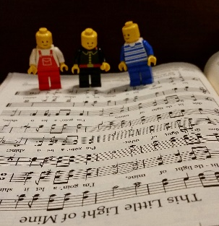
Make music! Singing offers children of all ages a way to participate. Encourage them to hum along before they are able to read the words. Encourage them to learn and sing the Doxology and refrains of hymns.
Nursery care is available during worship. Children must be signed in by a parent /guardian.

Offering! Pass the offering plate to your child, not past them. You may want to encourage your child to put some of his or her own money in the plate as their very own offering to God.
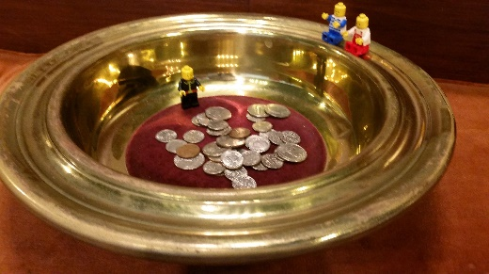
Participate! Children learn to be passionate about worship by watching you worship.

Questions are to be expected during worship. When your child asks a question, answer it briefly. This is less disturbing than saying "shhh" – and more welcoming! Come back during the week and learn the behind the scenes work that goes into worship and meet the pastors.

